First, the gateway product description
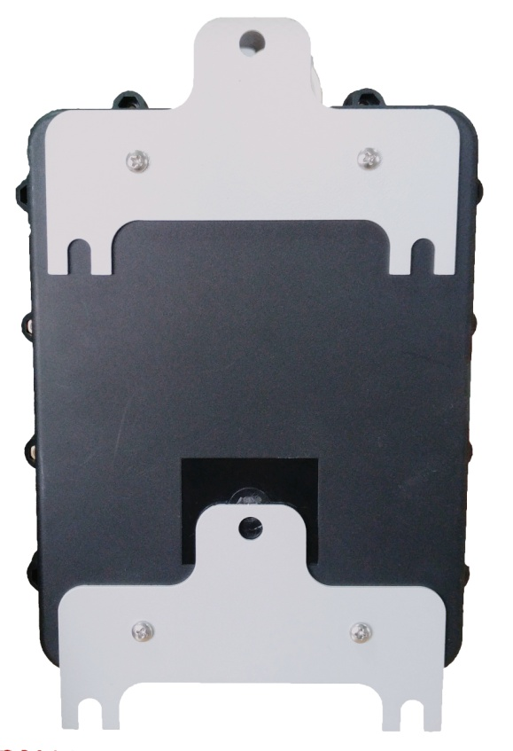
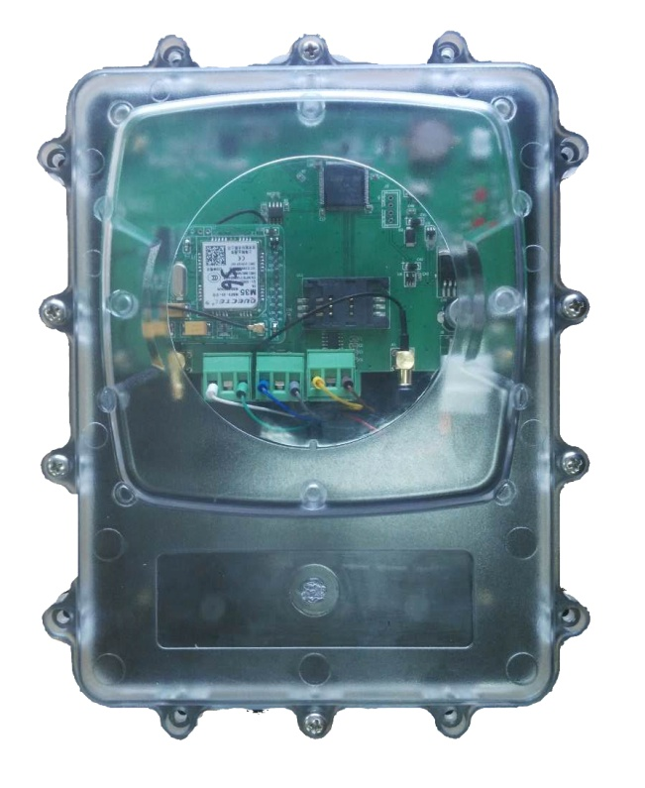
Mounting screw holes
Mounting screw holes
power cable,
Speaker interface
Antenna interface
Sealing screw hole
positive
back
Indicator light

Second, the gateway installation

1. The location where the gateway is suitable for installation
The gateway should be installed in the central area of the shelter (see Figure 1) to maximize the reception of all wireless smoke alarms. When the transmission distance between the gateway and the alarm is empty, the linear communication distance is 2 kilometers, and the actual transmission distance depends on the actual situation.
When installing on a wall, it is recommended that the gateway be at least 1.5 meters away from the ground to ensure smooth communication and avoid unnecessary damage to the gateway.

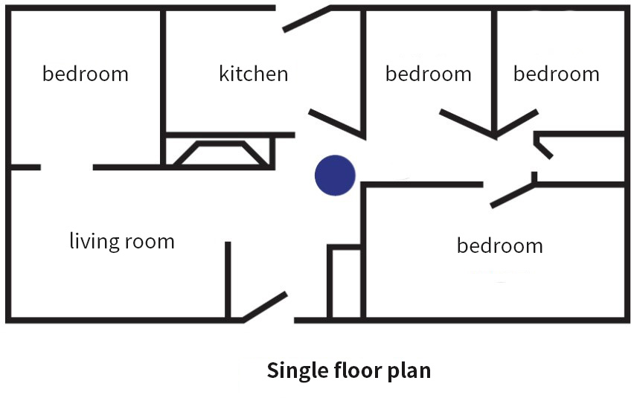
Figure 1

This example is a schematic diagram for home users when installing. For other users, please consult your local dealer or contact the company's customer service.

Third, random accessories
Power Adapter | 1
LoRa antenna | 1
Mounting screws | 3
Expansion nut | 3
User guide | 1
Certificate | 1

Fourth, technical information
Product number | XA-LoRa-AP01
Interface Type | LoRa
Communication frequency | 433MHz
Communication distance | 2km(empty distance)
Number of connections | 250
Transmit power | 20dbm
Receiving sensitivity | -124dbm
Communication rate | 4800bps
Wireless communication | GPRS/CDMA/WCDMA/LTE可选
Speaker interface | Can be connected to 2~5W speakers
Configuration interface | Configuration parameters can be configured through the serial port
working environment | -25℃～70℃，0%～95%RH
Operating Voltage | DC9V(DC5V～DC12V)
Working current | Maximum current: 2A； Average current: 100mA
shell | IP68 waterproof plastic case
size | 155mm * 215mm * 70mm

Five, product application scenarios
